Wi-Fi Training Program
Assignment Questions – Module 2
- Brief about SplitMAC architecture and how it improves the AP's performance
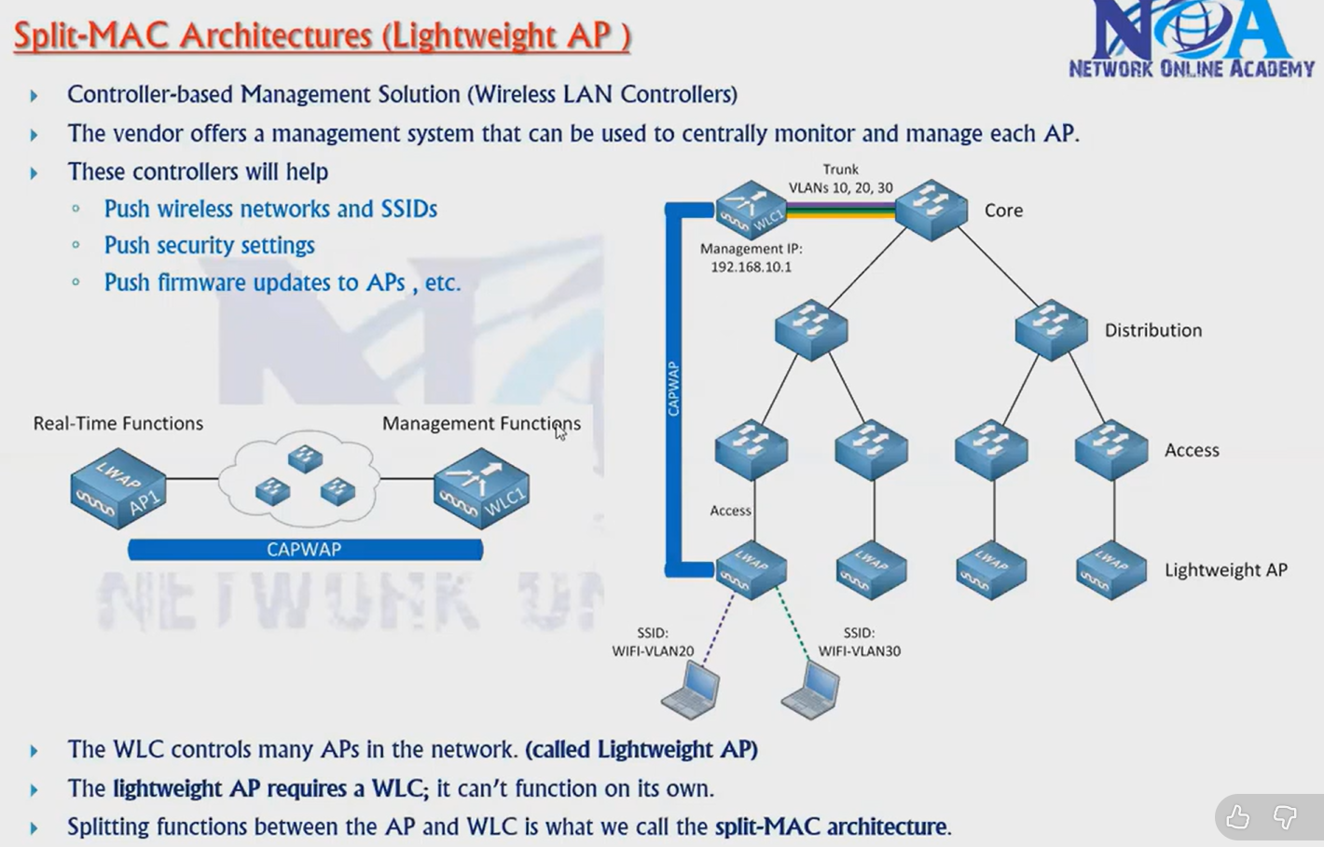
Split MAC architecture is also referred to as the Lightweight Access Point (LAP) mode, where a Wireless LAN Controller (WLC) is required to monitor and control multiple access points in a network.
In this architecture, the functions of an Access Point (AP) are divided into two categories:
- Real-time functions
- Management functions
The real-time functions are handled by the Access Point itself, while the management functions are handled by the Wireless LAN Controller.
Real-time functions include tasks such as transmitting beacons, handling probe requests and responses, managing client connections, performing encryption/decryption, and forwarding packets based on MAC addresses.
Management functions are carried out by the Wireless LAN Controller and include client authentication, SSID configuration, Quality of Service (QoS), power level management, and centralized control of multiple APs.
Thus, in Split MAC architecture, the MAC layer functions are divided between the AP and the controller. Part of the functionality is executed by the AP, and the remaining is handled by the controller. This centralized control simplifies management and improves scalability and overall network performance.
- Describe about CAPWAP , explain the flow between AP and Controller
CAPWAP and Flow between AP and WLC
CAPWAP (Control and Provisioning of Wireless Access Points) is a protocol used for communication between an Access Point (AP) and a Wireless LAN Controller (WLC). It enables centralized management of multiple APs by the WLC.
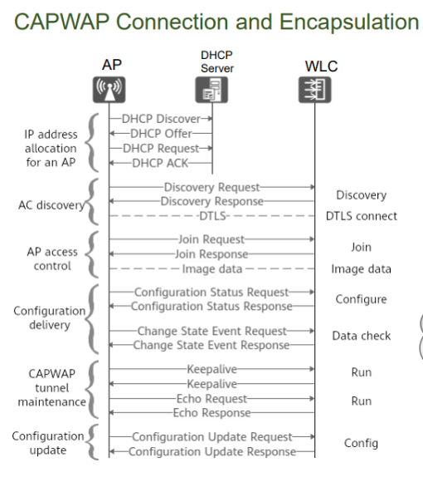
Flow between AP and WLC
- DHCP Process
When the AP is powered on, it obtains an IP address from the DHCP server. This allows the AP to communicate in the network.
- WLC Discovery
The AP discovers the WLC using methods like DHCP option, DNS, or manual configuration.
- Join Request
The AP sends a join request to the WLC, and the WLC responds with a join response to establish the connection.
- DTLS Security
A secure connection is established using DTLS (Datagram Transport Layer Security), which encrypts communication between AP and WLC.
- Firmware Check and Update
The WLC checks the firmware version of the AP. If it is not compatible, the AP downloads and installs the correct firmware from the WLC.
- Configuration Download
The WLC sends configuration details such as SSID, security settings, and channel information to the AP.
- Normal Operation
The AP starts functioning and serves wireless clients, while the WLC manages and monitors it.

- Where this CAPWAP fits in OSI model , what are the two tunnels in CAPWAP and its purpose
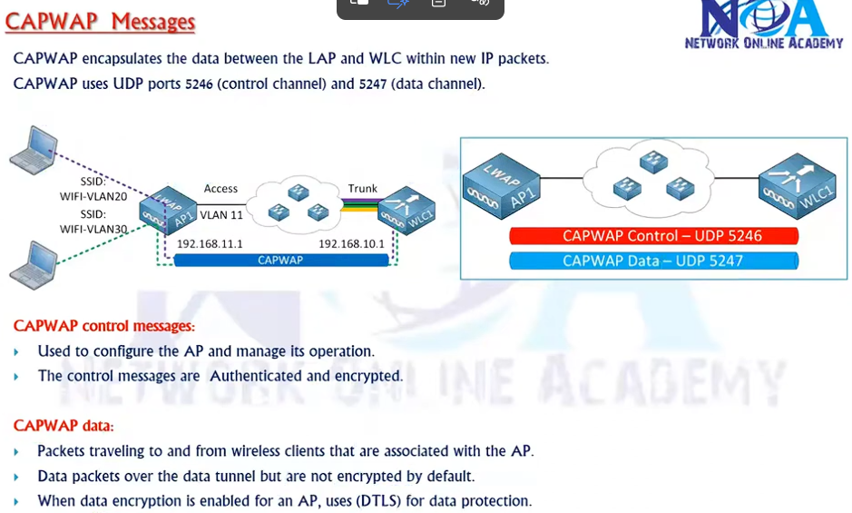
Aspect | Explanation
OSI Layer | Layer 3 (Network layer protocol using UDP)
Ports | UDP 5246 (Control), UDP 5247 (Data)
Tunnels | 1. Control Tunnel  2. Data Tunnel

- Whats the difference between Lightweight APs and Cloud-based Aps

Feature | Lightweight AP | Cloud-based AP
Controller | Needs WLC | Managed via cloud
Management | Centralized (local controller) | Remote (internet/cloud)
Dependency | Local network | Internet required
Use case | Enterprise campus  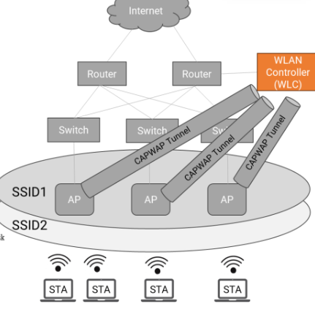 | Distributed networks / branches  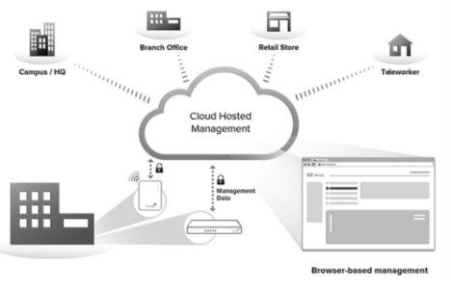

- How the CAPWAP tunnel is maintained between AP and controller
Transport Layer Security) to ensure encrypted communication, while the data tunnel transports client traffic. To maintain the connection, periodic keepalive or echo request and response packets (heartbeat mechanism) are exchanged between the AP and WLC. If a certain number of these packets are missed, the AP assumes that the WLC is down. In such cases, the AP attempts to re-establish the connection by rediscovering and rejoining the WLC using stored controller information in its memory, ensuring continuous and reliable network operation.
- Whats the difference between Sniffer and monitor mode , use case for each mode
Sniffer Mode
- AP acts like a packet capture device
- It captures all wireless traffic and sends it to a tool like Wireshark
- Used for deep troubleshooting and analysis
- Example: Checking packets, debugging network issues
Monitor Mode
- AP does not serve clients
- It only listens to the air (RF environment)
- Used for:
  - detecting rogue APs
  - interference
  - security threats
Example: Finding unknown/unwanted Wi-Fi devices

- If WLC deployed in WAN, which AP mode is best for local network and how?
FlexConnect allows access points to maintain a control tunnel to the WLC over the WAN while locally switching client traffic at the branch site. This means user data doesn’t have to traverse the WAN back to the controller, saving bandwidth and reducing latency. At the same time, the WLC still provides centralized management, policies, and monitoring when the WAN is available. If the WAN link fails, FlexConnect APs can continue serving clients using cached configurations or local RADIUS, ensuring service continuity.
- What are challenges if deploying autonomous APs (more than 50) in large network like university
Deploying more than 50 autonomous access points (APs)—also known as "fat" APs—in a large, high-density environment like a university creates significant operational, technical, and security challenges. Unlike controller-based systems, autonomous APs operate independently, making management exponentially more difficult as the network scales.
- What happens on wireless client connected to Lightweight AP in local mode if WLC goes down.
Condition | Outcome
Existing clients | Disconnect after timeout
New clients | Cannot connect
Reason | AP depends on WLC for control/data
Result | Network outage

